Pokhara University

Level: Bachelor | Semester – Fall | Year : 2009
Programme: BE |  | Full Marks : 100
Course: Network Theory |  | Time : 3hrs.

Candidates are required to give their answers in their own words as far as practicable.
The figures in the margin indicate full marks.

Attempt all the questions.

1. | - A series circuit containing R = 7 Ω, L = 1H and C = 0.1F is connected to 20 V dc supply at t = 0 sec. Find the expression of voltage across capacitor at any time using classical method considering inductor has zero current and capacitor has zero voltage initially.  - In the given RLC parallel circuit, determine v(0+),dv/dt(0+),d²v/dt²(0+)  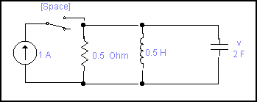  Assume no initial energy is stored. | 7  8
2. | - For the series circuit having R = 1Ω, C = 1/2F and L=1H with no initial voltage and current across the capacitor and inductor respectively. A voltage v = 10e^{-t} volts is applied at t = 0. Find the expression for the resulting current in the circuit for t ≥ 0.Use Laplace transform.  - State initial and final value theorems of Laplace transform. Find i(0) and steady state value of i(t) for the function I (s) =(s+1)/s(s+2). | 8  7
3. | - Find V_{2(s)} / V_{1(s)} for the following network. 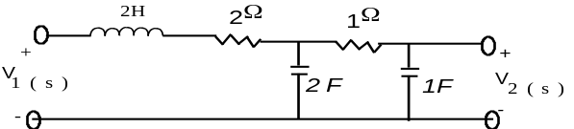  - Obtain the Fourier transform of the given wave form.  V(t)  -T/2  T/2  t | 7  8
4. | - Sketch the bode plot for the transfer function G (s) =75(1+0.2S) /S (S²+16S+100).  - Check whether the given function is PRF or not. 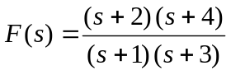 | 7  8
5. | - Check the stability of the following polynomial by applying Routh-Hurwitz criterion. Q(s) = S⁴ + 6S³ + 16S² + 26S +15  - Find the open circuit parameters of given network.  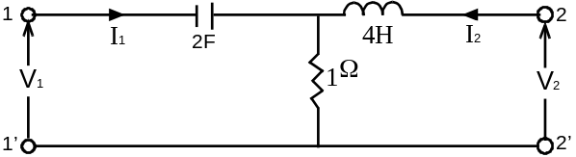 | 7  8
6. | - Find the equivalent T network for the given ∏ network.  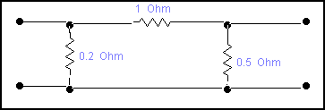  - Synthesis the foster –II and caur-I forms of RC driving Point function, Z_{RC} = 2(S+2)(S+4)/(S+1)(S+3). | 7  8
7. | Write short notes on (AnyTtwo)  - Transient and steady state response  - High pass filters  - Symmetrical and Reciprocal networks | 5×2

